**MOYVANE PARISH NEWSLETTER**

**Fr. Kevin McNamara, P.P. 🕿 089/4044816; Presbytery & Office 🕿 068/49308; Secretary: Jacqueline**

**Parish Office times: Mon & Thurs 10am – 12noon; Tues & Fri 10am – 1pm; Closed Wed.**

**Book Masses, Baptisms and Weddings during office hours. Thank You.**

[**www.dioceseofkerry.ie**](http://www.dioceseofkerry.ie) **E-mail:** [**moyvane@dioceseofkerry.ie**](mailto:moyvane@dioceseofkerry.ie)**.**

[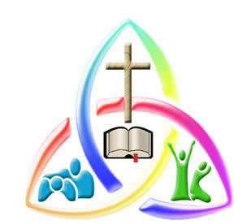](https://www.google.com/url?sa=i&rct=j&q=&esrc=s&source=images&cd=&cad=rja&uact=8&ved=2ahUKEwizw4fDsMndAhURXsAKHVCHCzgQjRx6BAgBEAU&url=http://www.fadajbcezeonwumelu.com/we-are-one-body-in-christ-rom-125/&psig=AOvVaw2rjPRyz1MFh-XTEgwq3wky&ust=1537525732584029) **Vigil and Sunday Masses – Saturday 22nd and Sunday 23rd September**

**MOYVANE:** Sat 22nd 7.30pm Deceased of Flavin & Mulvihill families, Lower Aughrim

**KNOCKANURE:** Sun 23rd 10.00am Parishioners

**MOYVANE:**   11.00am Joan Mulvihill, Moher (Anni)

**Church of the Assumption Moyvane: Friday 28th to Sunday 30th September**

Fri 28th 7.30pm Mikey Joe Enright, The Village (Anni)

Sat 29th 7.30pm Bridie Moore, Glenalappa (Months Mind)

Sun 30th 11.00am James Hartnett, Leitrim West (Anni)

& his parents Maurice & Mary

**Church of Corpus Christi Knockanure: Monday 24th to Sunday 30th September**

Mon 24th 12noon Funeral Mass of Timmy Horgan Jnr., The Nursery,

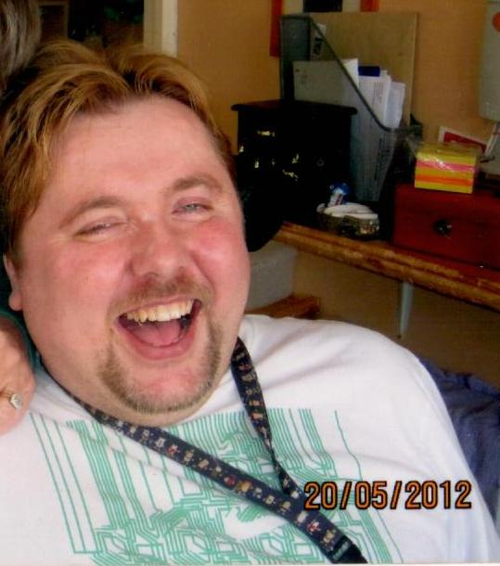 Trien & Killarney.

(Timmy’s funeral arrangements are as follows: Reposing at Finucane’s Funeral Home,

on Sunday from 4pm – 7pm. No removal on Sunday evening. Timmy Jnr’s remains

will arrive at Corpus Christi Church, Knockanure for 12noon Mass. Burial after

in Ahavoher Cemetery) Our prayerful support to his loving parents Timmy Snr and

Mary and family. May his gentle soul enjoy the delights of God’s Kingdom.

Sun 30th 10.00am Tom Flavin, Trien (1stAnni)

(please note this Mass will be held in Knockanure

Community Centre)



**DUTY THIS SUNDAY**: **Fr. Brendan Walsh, Causeway 🕿 087/7913271. Emergencies only.**

**EUCHARISTIC ADORATION:** KNOCKAURE: Closed. MOYVANE: Wednesday **10am – 7pm.**

**LAST WEEKEND’S COLLECTIONS:** Offertory **€1,296.05;** Dues **€281;** Shrines Moyvane **€205.**

**SECOND COLLECTION:** for Diocesan Needs will take place at all Masses this weekend.

**YOUR GENEROUSITY IS SIMPLY FANTASTIC:** I wish to acknowledge and appreciate your tremendous generosity to both the Offertory collections and to my Dues collections. These are difficult and hard times financially for all families and yet you continue to be exceptionally generous to both Churches in our Parish. Thank you. Please be aware that this coming week works continue in both Churches to ensure that they are in the best order for all our Church celebrations. Very many thanks to the wonderful volunteers who have beautified and delightfully enriched the back of Knockanure Church. A lovely new fence and lovely topsoil (the latter which was very generously donated by a parishioner) has made a huge difference.

**PRAYERS & SYMPATHY:** To Andrew Rogan and family, Lisaniskea on the death of his loving mother Vivienne, Caherdavin, Limerick whose beautiful funeral Mass took place in Christ the King Church, Caherdavin last Tuesday. To the Costello family, l/o Trien on the death of John Costello in England. Mass for John will be celebrated in Knockanure on Sunday 21st October at 10am. May Vivienne and John Rest In Peace.

**KNOCKANURE CHURCH CLOSED:** from Tuesday 25th September to mid-October. Sunday Masses will be in Knockanure Community Centre. Very many thanks to all in the Centre for their very generous help in accommodating once again. In the interest of health and safety, we ask that people do not enter the Church while the works are being carried out. Eucharistic Adoration in Moyvane only on Wed’s. Thank you.

**ALTAR SERVER CELEBRATION:** In thanking the Altar Servers who have completed their time as Servers in both Churches, we will be having a Mass of thanksgiving on Sunday 11th November. The outgoing Servers will be presented with a plaque in recognition of their dedicated Ministry of Altar Serving. This will be followed by an outing with their parents and the Server Co-ordinators Bernie & Liz.

**PASSPORT TO HEAVEN**

One day you and I will depart on our final journey from this life. The late Fr. John, whom you loved and appreciated told you time and time again that he would be the last P.P. in Moyvane. He wasn’t! God rest him. But when you and I depart this life, it will be cost free. No need to worry about reserving a seat. It’s already reserved. The flight will be on time. We’re guaranteed that. Our good deeds and our acts of kindness will be our luggage. Helping parishioners who feel excluded, sad, poor and vulnerable will be our visa. “As long as you did it to one of these you did it to me”. And charity will be our passport. All you and I need to make sure we travel economy class. Can I tell you on this kind of journey, it’s much safer than business class. We are privileged in our Parish to have the Lyons’s of Derry, Listowel and Finucane’s of Keylod as fantastic undertakers who are so, so supportive of families in grief. We thank them for all the love, help and sensitivity. May God continue to bless them in the very sensitive and loving work they do with us at times of funerals. Currently, I am looking at my own passport with a view to my first foreign holiday since I have come to the Parish in July 2015. Thank God it’s intact. I hope my passport to Heaven will be equally intact. How is your passport to Heaven?

**SANCTUS (HOLY HOLY ……….SO VERY IMPORTANT)**

Though originally not part of the Eucharistic Prayer the Sanctus (“Holy, Holy”) is sung after the preface. It contains echoes of the account of the call of the wonderful prophet Isaiah of the vision of John in the 4th chapter of the lovely book of Revelation. It is a declaration of God’s holiness, God’s otherness. All creation is united in heaven and on earth is proclaiming this. It is a high point in the Eucharistic Prayer and this is made clear when it is sung. (Our excellent Choirs - no pressure - but the Holy, Holy Lord sung make our Masses extra special!)

**NOTICES**

**GREAT GAA DAYS:** Feale Rangers won the u16’s County Plate beating Castleisland District in a sensational final. The Parish had two representatives on it Mícheál Fogarty (Captain) and Mícheál Kissane. Our Parish u14’s had a great win over Ballyduff in the North Kerry Championship Div 1 Final on a score line of 5-19 to 5-13. Captain T.J. Mulvihill. Meanwhile across the Estuary the Cooraclare Seniors beat the mighty Doonbeg (Magpies) on a score line of 15 points to 1-7. Cooraclare advance to meet Podge Collins & Co., the Cratloe team. Great days all round for GAA enthusiasts. Well done to all the winning teams.

**MOYVANE PARENT AND TODDLER GROUP:** A meeting will be held Wednesday 26th September at 10.30am in the Marian Hall to discuss the future of the group. If you have an interest in this group it is important that you attend. Any queries contact Laura 087/9206421.

**PARISH PASTORAL COUNCIL:** wish to thank the Community Enhancement Programme & Department of Rural & Community Development for the grant towards helping us clear and plant at the rear of the Church in Knockanure.

**LISTOWEL FAMILY RESOURCE CENTRE:** Basic, Intermediate and Benefit 4 computer courses beginning in October. To register contact Bridie 068/23584.

**TOASTMASTERS:** If you want to gain confidence, become a better speaker, meet new people and have a good night out, then come along to Listowel Toastmasters! The first meeting of the new season will be held at the Listowel Arms Hotel at 8pm on Thursday September 27th.  New members and guests always welcome

**CALLING ON MAN U, CELTIC, JOHN DELEANEY AND THE IRISH TEAM**

The GAA and in particular the Cork County Board have had awful press and awful comments made about them concerning the Liam Miller Testimonial which will take place in Páirc Uí Chaoimh this Tuesday. We all wish Liam’s loving family blessings and good fortune for the future and please God Tuesday’s Testimonial will benefit them financially. However, that financial gain could be a lot bigger and better if Man United, Celtic and the FAI get involved even at this late stage. I call on them to match between the three of them what is raised from the game at Páirc Uí Chaoimh. It is a once off game and the chances of having similar games to this in the future are very remote. Over to you Man U, Celtic and FAI.

**TEN SECOND SERMONS**

* Life is fragile – treat it with prayer.
* Lord, through this hour be Thou my guide. That by Thy power no foot shall slide.
* Any concern too small to be made into a prayer is too small to be made into a burden.