**MOYVANE PARISH NEWSLETTER**

**Fr. Kevin McNamara, P.P. 🕿 089/4044816. Presbytery & Office 🕿 068/49308; Secretary: Jacqueline**

**Parish Office times: Open Mon & Thurs 10am – 12noon; Tues & Fri 10am – 1pm; Closed Wed.**

**Book Masses, Baptisms and Weddings during office hours. Thank You.**

[**www.dioceseofkerry.ie**](http://www.dioceseofkerry.ie) **E-mail:** [**moyvane@dioceseofkerry.ie**](mailto:moyvane@dioceseofkerry.ie)**.**

**Vigil and Sunday Masses – Saturday 3rd and Sunday 4th November**

**MOYVANE:** Sat 3rd 7.30pm Parishioners

**KNOCKANURE:** Sun 4th 10.00am Michael Culhane, Ballyguiltenane (Anni)

& deceased of the Culhane & Sheahan families

**(Mass in Knockanure Community Centre)**

**MOYVANE:**   11.00am Tim O’Connor, Inchamore & Sligo (Anni)

[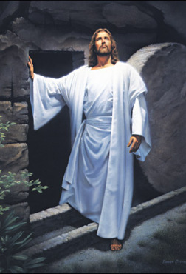](https://www.google.com/url?sa=i&rct=j&q=&esrc=s&source=images&cd=&cad=rja&uact=8&ved=2ahUKEwj__7fwm7PeAhWDfFAKHRk4BOUQjRx6BAgBEAU&url=http://bulletin.equinoxpub.com/2010/10/odds-on-the-resurrection-of-jesus-100000000000000000000000000000000000000000000-to-1/&psig=AOvVaw3yNlSb3sZW1Dok0_v16PPC&ust=1541162482748571)**Church of the Assumption Moyvane: Monday 5th to Sunday 11th November**

Mon 5th 7.30pm Special Intention (Teresa)

Tues 6th 7.30pm Mass for all the deceased members of the ICA

**(Mass in the Marian Hall – all welcome)**

Wed 7th **7.00pm** First Holy Communion Enrolment Ceremony (no Mass)

for Murhur N.S. **(in the school – all welcome)**

Thurs 8th 7.30pm For all the deceased on the November Lists

Sat 10th 7.30pm For all the deceased on the November Lists

Sun 11th 11.00am Mass for all Altar Servers & their families

**Church of Corpus Christ: Friday 9th to Sunday 11th November**

Fri 9th 7.30pm Michael Lane, Beenanaspig (Anni)

**(Mass in Knockanure Community Centre)**

Sun 11th 10.00am Jerry Enright, The Village, Knocnanure (Months Mind)



**PRIEST ON DUTY THIS SUNDAY**: **Yours truly 🕿 089/4044816. Emergencies only.**

**EUCHARISTIC ADORATION:** KNOCKAURE: **Closed.** MOYVANE: Wednesday **10am – 7pm.**

**LAST WEEKEND’S COLLECTIONS:** Offertory **€1,578.01;** Renovation Fund **€6,045;** November Offerings **€1,265.** Offertory All Saints **€267.46.** Very many thanks for your tremendous generosity.

**SECOND COLLECTION:** At all Masses next weekend 10th/11th in aid of Irish Church Commissions & Agencies.

**PRAYERS & SYMPATHY:** To Mary, Mike and Daniel Stack, Keylod and all in their extended family on the death of David whose funeral took place in Moyvane last Wednesday. Our prayerful support continues to be with them. To Nora Fitzmaurice and Mary Lyons and families on the death of their nephew Jamie McCoy, Abbeyfeale whose funeral took place on Friday. We extend our prayerful blessings to the McCoy family and Fergus O’Keeffe and staff where Jamie worked so diligently. May David and Jamie Rest In Peace.

**TWO SPECIAL DATES FOR YOUR DIARY:** We will remember and honour the faithful departed whose funeral Masses took place in Knockanure and Moyvane from November 2017 to November 2018. A special memorial candle will be given to families of the aforementioned. Knockanure Mass will be on Monday 19th November at 7.30pm and on Monday 26th November in Moyvane. I would appreciate if you could inform people living outside the Parish that are associated with these funerals of the above dates.

**MEMORIAL MASS:** will be held for deceased members of Kerry Ingredients, Listowel in St Michael's Church, Lixnaw on Wednesday 7th November at 7.30pm. All welcome.

**ARDFERT RETREAT CENTRE: Celebrate your Faith:** Elizabeth Gilmartin, Mon. 12th, 19th, 26th Nov 7.30-9pm.

**Ardfert History Society:** Tommy O' Connor, The demise of the "Big Houses" including the Crosbie departure from Ardfert. Thurs 8th Nov 8pm.

**Self Care Day**: Anna O'Donoghue, I.A.C.P. Practical skills to promote self-care and wellbeing. Sat 10th Nov 9.45am-4pm. Contact: Anna 087/9447105.

**Advent Retreat: Fr. Gerard McCarthy SVD:** Fri. 14th - Sun 16th Dec. Book Now.

[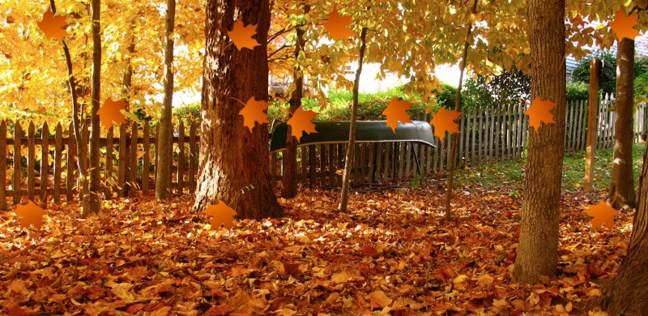](https://www.google.com/url?sa=i&rct=j&q=&esrc=s&source=images&cd=&cad=rja&uact=8&ved=2ahUKEwiFgomQm7PeAhVQPFAKHXc0AgsQjRx6BAgBEAU&url=https://premiumcoding.com/css3-tricks-falling-leaves-css/&psig=AOvVaw0ZmJhlhU5om6O2-mjCIsI9&ust=1541162273751347) **NOVEMBER - WE REMEMBER**

As a Church, we always remember our faithful departed in this month of November. Even those who believe neither in God nor in the Resurrection will still remember their dead and their deeds. As followers of Jesus, our remembrance of our dead is faith based. We recognise and recall what they have done in this life but we also acknowledge that they live on, and hope one day to be reunited with them. We remember them, but before God, which is another way of saying that our remembrance of them is a prayerful one. Some words I recall from our family Bible of my youth: “It is a holy and wholesome thought to pray for the dead, that they may be loosed from their sins”, and it occurs to me that it is also holy and wholesome for you and I to think about our own death and to pray that it may be a good and happy one. The only certainly we have in life is that we are all going to die. There is no way we can escape that. Most of us are reluctant to think about our own death and we condemn talk of death as morbid. Granted there can be an unhealthy preoccupation with death. I consider it just as unhealthy to flee from thinking about it. It is as natural as birth and we who claim to be followers of our Risen Jesus sharing already in His new and eternal life should be ready to think from time to time of our own death and prepare for it. I invite you to come to the November Masses for all named on the November lists. These Masses will bless both our faithful departed and ourselves as well.

**“ACTUALLY THIS IS ALL WE NEED FOR TODAY”**

Way back in 2000 I was giving Missions in the States. At that time there were many crazy game shows on television. The one that I got great fun from was “Knockout”. Crazy competitions where anything goes, one of the tests had three people in a supermarket each with an empty trolley. At the sound of a whistle, they had two minutes to dash around the aisles, filling the trolleys with all sorts of goods. When the whistle sounded again, they had to go to the checkout, where all goods in each trolley were checked on the cash register. The one with the most valuable trolley was declared the winner. As they were waiting for the checkout to be completed it was common to see someone look in another’s trolley and remark, “Oh, I’m sorry I didn’t see that. I should have taken more of those items when I was at it”. Seldom is anyone happy with the result, because they were under such pressure that there was no time to think in the midst of the crazy scramble. Now let us put two more trolleys into the competition, except this time, these two, a woman and a man, are people who take Jesus seriously and who rely and live on His Commandments and promises. The whistle blows and they’re off. Then with these two there is no mad scramble. The two are very calm as they stroll along, picking up a loaf of bread here and a pound of butter there. When one of the ‘crazy bunch’ drops something from a trolley, one of our friends picks it up and puts it back on the trolley that dropped it. Time is up and all six report to the checkout. Imagine the looks of the four when they looked into the trolleys of our two friends! There is just too much for one of the four who berate them. “Who on earth let you two out? Didn’t anyone tell you what this is all about? Where are you going with a loaf of bread and a pound of butter and a bottle of milk? Were you not told this is a competition and the one with the most is the winner?” The two calmly replied, “Actually this is all we need for today. You see our father owns the supermarket”. November focuses the mind and heart in the realisation that none of us will live forever. We are all just passing through. Just look at the past and see all those who are gone to their eternal home. The two in the supermarket who trusted in Jesus had the right idea. All we need for today is His presence, blessing and protection. Make it a November to remember. Be assured of my prayers.

**NOTICES:**

**SENIOR CITIZENS CHRISTMAS DINNER:** Dinner, dancing and afternoon tea in the Marian Hall on November 18th. Mass at 12.30pm. Please book with Ita on 068/49134 or Maureen 068/49365.

**MOYVANE ICA:** wish to acknowledge with thanks the receipt of a grant for €1000 from Kerry Co. Council under the Community Enhancement Programme 2018. This money will be used to purchase equipment for the kitchen in the Marian Hall and to carry out repairs to storage cupboards.

**TICKETS FOR CONCERT FUNDRAISER:** In aid of Ard Cúram Day Care Centre, Listowel (towards the new dementia unit) are on sale in the Parish Office and after all Masses this weekend. Your support would be deeply appreciated. €10. If you wish to buy a ticket but are unable to go please put your name and contact number on the stub and it will be entered in the draw for two tickets to the Late Late Show.