**MOYVANE PARISH NEWSLETTER**

**Fr. Kevin McNamara, P.P. 🕿 089/4044816; Presbytery & Office 🕿 068/49308; Secretary: Jacqueline**

**Parish Office times: Mon & Thurs 10am – 12noon; Tues & Fri 10am – 1pm; Closed Wed.**

**Book Masses, Baptisms and Weddings during office hours. Thank You.**

[**www.dioceseofkerry.ie**](http://www.dioceseofkerry.ie) **E-mail:** [**moyvane@dioceseofkerry.ie**](mailto:moyvane@dioceseofkerry.ie)**.**

**Vigil and Sunday Masses – Saturday 8th and Sunday 9th September**

**MOYVANE:** Sat 8th 7.30pm Patrick Brosnan, Moyvane South (Anni)

**KNOCKANURE:** Sun 9th 10.00am Kitty Murphy, Kilmorna (Anni) & her husband Jackie

**MOYVANE:**   11.00am Nora & Mick Roche, Glin Road (Anni)

[](https://www.google.com/url?sa=i&rct=j&q=&esrc=s&source=images&cd=&cad=rja&uact=8&ved=2ahUKEwj5kv3YnqHdAhULXsAKHSWIDZEQjRx6BAgBEAU&url=http://deaconpathomily.blogspot.com/2012/09/am-i-blind-homily-23rd-sunday-ordinary.html&psig=AOvVaw3Q0astg9JLNaMEjSCOjEHB&ust=1536146721184616)**Church of the Assumption Moyvane: Wednesday 12th to Sunday 16th Sept**

Wed 12th 7.30pm Hanora & Michael Galvin, Barragougeen (Anni)

& deceased of the Galvin family

Thurs 13th **11.30am** Murhur N.S. – Start of year Mass (in the Church)

All welcome

Sat 15th 7.30pm Special Intention - sick

Sun 16th 11.00am Paddy Fitzmaurice, Gurtdromosillihy (Anni)

**Church of Corpus Christi Knockanure: Tuesday 11th to Sunday 16th Sept**

Tues 11th 7.30pm Mary O’Connor, Keylod (Anni)

Sun 16th 10.00am Parishioners



**DUTY THIS SUNDAY**: **Yours truly 🕿 089/4044816. Emergencies only.**

**EUCHARISTIC ADORATION:** Please note that there will be NO Adoration in either Church this coming week due to the Listowel Races. Adoration resumes on Tuesday 18th and Wednesday 19th at usual times.

**LAST WEEKEND’S COLLECTIONS:** Offertory **€1,466.56;** Shrines Knockanure **€54.11.** Many thanks.

**DUES COLLECTION:** Very many thanks for your most generous contributions to last weekend’s Dues collection. It amounted to **€2,790**. Thank you so very much.

**DIOCESAN NEEDS COLLECTION:** this collection has been deferred to the weekend of 22nd /23rd as the designated day would have clashed with other collections. Your generous support would be deeply appreciated.

[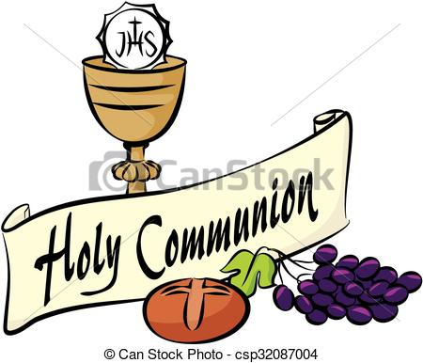](https://www.google.com/url?sa=i&rct=j&q=&esrc=s&source=images&cd=&cad=rja&uact=8&ved=2ahUKEwibgueJnaHdAhXrIMAKHdWfAM4QjRx6BAgBEAU&url=https://www.canstockphoto.ca/holy-communion-32087004.html&psig=AOvVaw2M_sDC3nURsjMl1EWZgOIo&ust=1536146268234840)**HOLY COMMUNION DATES FOR 2019:** Our two National Schools have informed us that Holy Communion dates for 2019 are as follows:

**Scoil Chorp Chríost, Knockanure – Sat May 11th at 11am.**

**Murhur N.S. Moyvane – Sat May 25th at 11am.**

We wish all involved God’s blessing in their preparation for

their First Confession and their First Holy Communion.

**BE REALLY CAREFUL ABOUT YOUR THOUGHTS!**

I don’t know much about the teachings of ancient Greek philosophers – Aristotle, for example – but it is some comfort to know that I am not alone in this. We ordinary mortals find we can get along quite nicely without burdening our brains with abstract ideas. I was encouraged too, to read that Aristotle’s ideas were not always correct as a modern philosopher Betrand Russell showed when he wrote:

“Aristotle could have avoided the mistake of thinking that women have fewer teeth than men by the simple device of asking his wife Mrs Aristotle to keep her mouth open while he counted. He did not do so because he thought he knew. Thinking that you know when, in fact, you don’t is a fatal mistake”. Or as my old teacher once said, “Do you know what thought did? He didn’t, he only thought he did!”.

**DECISIONS**

Last year Tom was offered a job for double the salary of his present teaching position. It was an attractive offer. Yet, after talking it through with his family, he turned it down. His wife explains their decision: “Tom is a father figure at school. Many children confide in him about their personal hassles. We estimate he saves at least one teenager from suicide and one baby from being aborted each year. Even if they pay him double the salary at a new job, it’s just not worth it”. Think of a situation where you can easily take people for granted. How can you change your behaviour in this regard?

[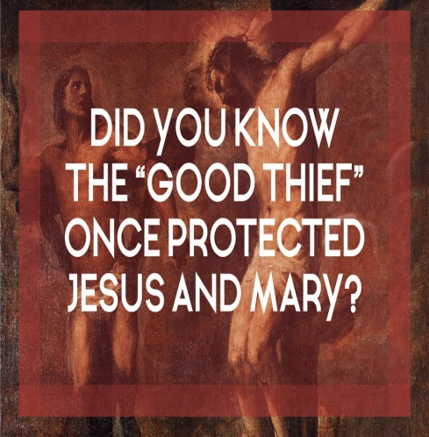](https://www.google.com/url?sa=i&rct=j&q=&esrc=s&source=images&cd=&cad=rja&uact=8&ved=2ahUKEwjKsKvtlqHdAhWLC8AKHSiQAzsQjRx6BAgBEAU&url=https://beecatholic.com/does-this-ancient-document-show-the-real-reason-why-jesus-forgave-the-good-thief-jesus-and-mary-had-met-him-before/&psig=AOvVaw1bbX4GvQ9FsHq6ACm5CWPn&ust=1536144607412587) **JESUS WAS CRUCIFIED BETWEEN TWO THIEVES**

There is a lot anger and grief about clerical sexual abuse and cover-up in our Church. Apologies have been almost universally sincere, and we all witnessed Pope Francis last weekend giving a heartfelt sorry and apology for the awful abuse, yet the awful hurt remains. There is so much grief around the issue that words, even right ones, generally don’t hit their mark, akin to telling someone freshly grieving the death of a loved one that “she’s in a better place”. The words are true, but the moments too raw for the words to be heard. They only become effective later and that’s the situation now; we’re in a time of raw anger and dark grief. Apologies while necessary are not being heard. The moment is too raw. What has happened in our Church in terms of sexual abuse by clergy and cover-up by the hierarchy is inexcusable, deeply sinful, has harmed thousands of lives irrevocably and needs urgent redress in terms of reaching out to victims and of prompting structural change in our Church to ensure that this will never happen again. The Pope’s visit touched me deeply, despite the fact I could not attend in person, but watched RTÉ’s excellent coverage on television. Through the whole experience, I found myself thinking of Jesus on the Cross. Jesus was crucified between two thieves. He was innocent, the two thieves weren’t, but he didn’t protest His innocence and those looking at the three crosses that day did not distinguish between who was innocent and who was guilty. As a Priest I do not distance myself from those who have done wrong by saying: “They’re guilty and I’m not!” There are times when one does not protest one’s innocence. Part of Jesus’ mission, to risk having His innocence mixed in with guilt and be perceived as sin so as to help carry darkness and sin for others. Beyond our apologies, all of us, clergy and laity alike are invited to do something for the Church right now, namely, help carry this scandal as Jesus did. Indignantly separating ourselves morally from this awful sin is not the way of Jesus and the Cross. Let’s imitate our Blessed Lady at the foot of the Cross. Mary’s inward voice is not of bitterness, anger or revenge rather it’s as follows: “Today, I can’t stop this darkness, nobody can. Sometimes darkness just has it’s hour. But I can stop some of the sin and bitterness that’s in the moment by absorbing it and not giving back in kind”. Our response as followers of Jesus can’t continue to distance ourselves from the awful sin of abuse but rather a need to help absorb it. We need to continue to pray and wait.

**NOTICES**

**IRISH HEART FOUNDATION**: Annual Church gate collection will take place on the 15th/16th September.

**THE IRISH CANCER SOCIETY’S NATIONAL CONFERENCE:** in the Clayton Hotel, Silver Springs, Cork on Sat Sept 22nd from 10am – 4pm. The aim is to provide information and support to cancer survivors, those who care for them, health care professional and staff / volunteers from cancer support services. Topics include exercise, diet, mindfulness, employment and more. Info Breda on 01/2310533, email [bcuddihy@irishcancer.ie](mailto:bcuddihy@irishcancer.ie) or go to [www.cancer.ie](http://www.cancer.ie) to register. The conference is free of charge but registration is essential.

**LISTOWEL FAMILY RESOURCE CENTRE:** Rainbows offers a 9 week listening, group support programme for children following a bereavement or parental separation.

•     Children will be grouped together depending on their age and loss experience.

•     Rainbows is suitable for children from age 7 years and in 1st class up to 6th class.

•     Rainbows is not counselling or professional therapy.

Parents are invited to visit [www.rainbowsireland.ie](http://www.rainbowsireland.ie) Start date: 19th September at 5.15pm. Info - Toni on 23584.

[](https://www.google.ie/url?sa=i&rct=j&q=&esrc=s&source=images&cd=&cad=rja&uact=8&ved=2ahUKEwj1m63JoKHdAhVSWsAKHQKOBekQjRx6BAgBEAU&url=https://twitter.com/listowelraces&psig=AOvVaw1qkom8e3KF3NcNrkQOmZT4&ust=1536147240147464)**THIS YEAR LISTOWEL CELEBRATE THE 160TH**

**ANNIVERSARY OF THE RACES**

It’s simply incredible and quite extraordinary that the Listowel Races celebrates its 160th Anniversary this year. Its success and longevity is down to the fantastic support that is received from everyone but especially from all the Parishes in North Kerry, including our own. From this Sunday 9th to Saturday 15th Parishioners will take days off to enjoy the Racing, the atmosphere and the ambience of a truly magnificent racing festival. Listowel that wonderful town of hospitality, song and story and a great sense of fun richly deserves the benefits it will bring to the whole town. We pray that the weather will be kind and for all who attend that they will enjoy themselves fully and that everything will go off safely. Enjoy!